NEPAL COLLEGE OF INFORMATION TECHNOLOGY
Level: Bachelor Assessment Year: 2014
Program: BEIT II Full marks: 100
Course: Electronic Devices Time: 3hrs

Attempt all the questions
- a) Differentiate between linear and nonlinear devices. Taking an appropriate example, show that nonlinear device doesn’t follow principle of superposition. (8)
b) How depletion region is formed in a diode. Explain with the help of band structure of PN junction diode. (7)

2. a) What happens when a forward biased diode is suddenly reverse biased?
Explain with necessary diagrams. (5)
b) What do you mean by dynamic resistance of diode? Show that dynamic resistance of diode r_{D}=ηV_{T}/I. (5)
c) Explain piecewise linear modeling of PN junction diode. (5)

3. a) What do you mean by diode breakdown? Explain how breakdown occurs in zener diode. (7)
b) Explain Tunelling Phenomenon of tunnel diode and draw its VI characteristics. (8)

4. a) The Zener diode ratings connected in the circuit shown below is 8V, 2mA. Find the value of series resistance R so that the output across the load is regulated. (7)
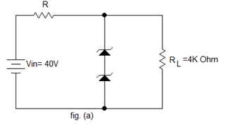

b) Explain the working principle of NPN transistor with necessary diagram. Show that I_{C}=βI_{B}+(β+1)I_{CBO}.(8)

- a) What is transistor configuration? Explain input and output characteristics of CE transistor configuration. (7)
b) Explain EM model of a BJT and derive the expressions for the transistor currents for this model. (8)
OR
- What do you mean by transistor biasing methods? Which is the most appropriate BJT biasing method? Explain with reasons. (8)
- For the BJT circuit shown below, draw dc load line and locate operating point on it.
(assume β=100) (7)
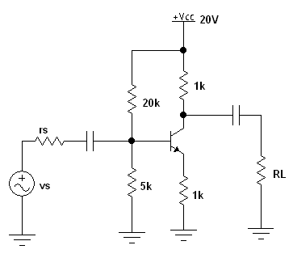

6. a) Explain the operation of Bridge full wave rectifier. Find its efficiency, ripple factor and PIV. (8)
b) Draw the output waveform (assume silicon diode). (7)
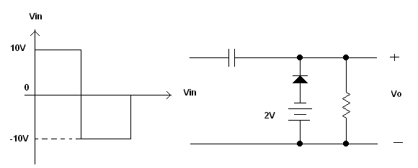

7. Write short notes (any two). 2×5
a) Diode Capacitances
b) BJT Amplifier
c) Schottky Diode
d) Transistor Switching Times

